Information Sheet
Location, Aquarium Instructions, Parking, Public Transit, Dining

Location:
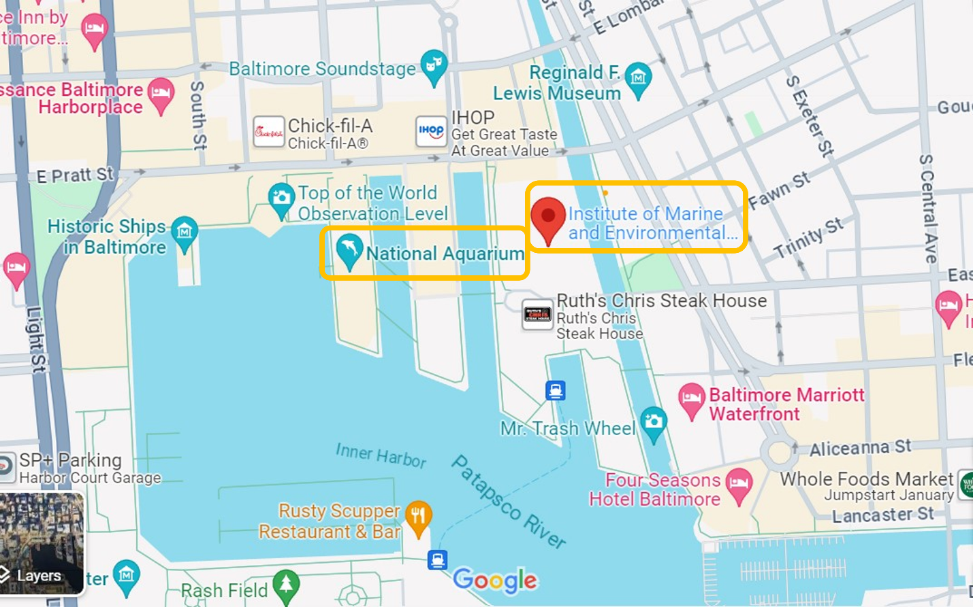
Institute of Marine and Environmental Technology – daytime scientific meeting – 9am-6pm
Pier V
701 E. Pratt Street
Baltimore, MD 21202

National Aquarium – evening buffet reception with exhibit visit; 6:15-9:30pm
Pier III
501 E. Pratt Street
Baltimore, MD 21202

Instructions for Aquarium Reception:
Guests will arrive at the Aquarium starting at 6:15 pm at the main entrance and can arrive as late as 6:30. If guests arrive after 6:30, they will be sent directly to the Dolphin Viewing Area without a chance to walk through the Aquarium.
The reception is from 7:00-9:30 pm in the Dolphin Viewing Area with access to the Jellyfish Exhibit. Aquarium staff will make sure everyone arrives at the reception at 7pm.
Each guest will receive two drink tickets.

Parking:

Pier V Parking – 711 E. Pratt Street, Baltimore, MD 21202 – same pier as IMET - parking will be validated at $15 for the entire day. You must pick up a parking voucher from Meredith in order to receive the $15 rate. The garage is open 24 hours however the voucher expires at midnight.

Public Transit:

LightRail – Use the Convention Center stop or the Camden Yards stop to get to IMET from points northbound or southbound – trains run late into the evening – regular fare is $2, student fare is $1.50 one-way, round-trip passes available – station parking is free, suggestion is to park at a stop outside the city - stations at Lutherville and north, and North Linthicum and south, should have ample parking – see https://www.mta.maryland.gov/schedule/lightrail for more information

Dining Near IMET (for lunch):

Inner Harbor:
Docks on the Harbor – Pier IV – near Hard Rock Café
Hard Times Café – Pier IV – near Docks on the Harbor
Blackwall Hitch – Pratt Street, inland side
Chipotle – Pratt Street, inland side
Shake Shack – Pratt Street, inland side
Miss Shirley’s Café – Pratt Street, inland side
Cheesecake Factory – Pratt Street Pavilion

Little Italy:
Vaccaro’s Italian Pastry Shop
La Tavola
Amicci’s
Isabella’s Brick Oven Pizza
Dalesio’s
Sabatino’s
Chiapparelli’s
Café Gia Ristorante
Angeli’s Pizzeria

Harbor East:
Bambu Baltimore - Vietnamese
James Joyce Irish Pub and Restaurant - Irish
Maximón - Mexican
Taco Fiesta - Mexican
Bambao - Chinese
Lebanese Taverna – Lebanese/Mediterranean
BLK Swan - American
Whole Food Market - Various
RA Sushi Bar - Japanese

